Hythe 2000
IT 4 All

Label Printing

Step by step to print labels (Avery J8160 3 x 7)
https://www.avery.co.uk/blank-labels/rectangle-64x38mm (£26 odd for 100)
or
https://www.amazon.co.uk/dp/B004TGK6QO ( £17 for 100)

Fictitious list of names and addressed enclosed below

1. Visit https://www.avery.co.uk/

2. Select Design and Templates
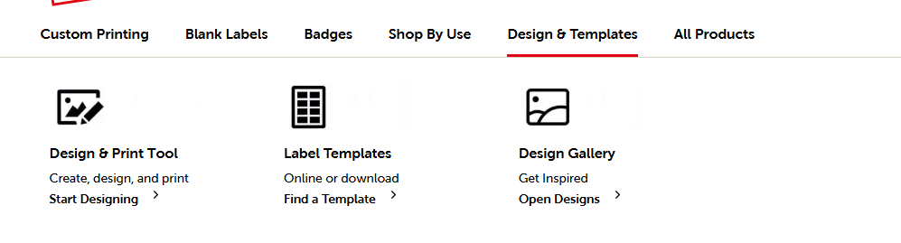
3 Select Design and Print Tool

4. Select 1 – Choose Template

5. Select Avery J8160
6. There’s lots of predefined templates for all sorts of things, we’ll keep it simple and select the first box
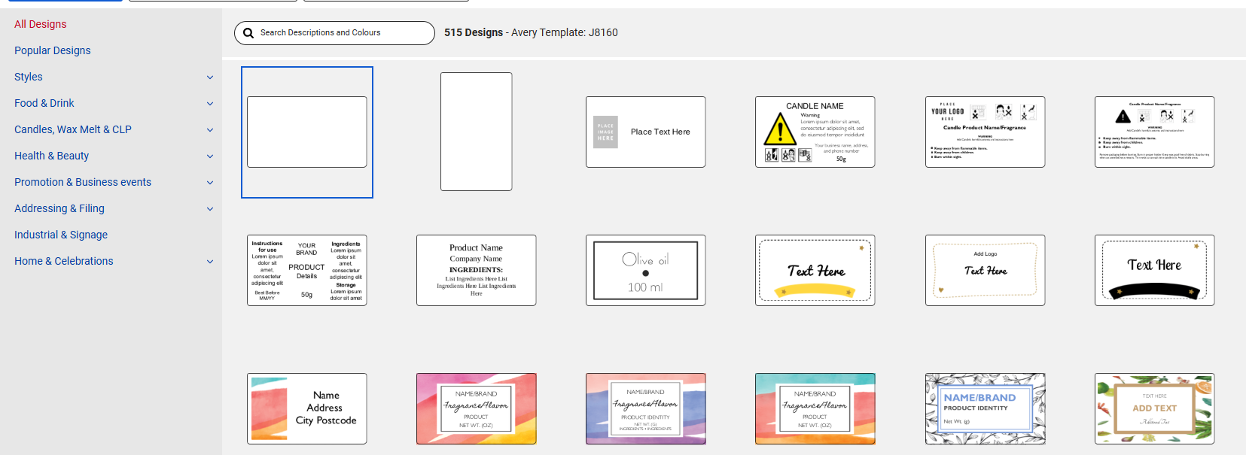

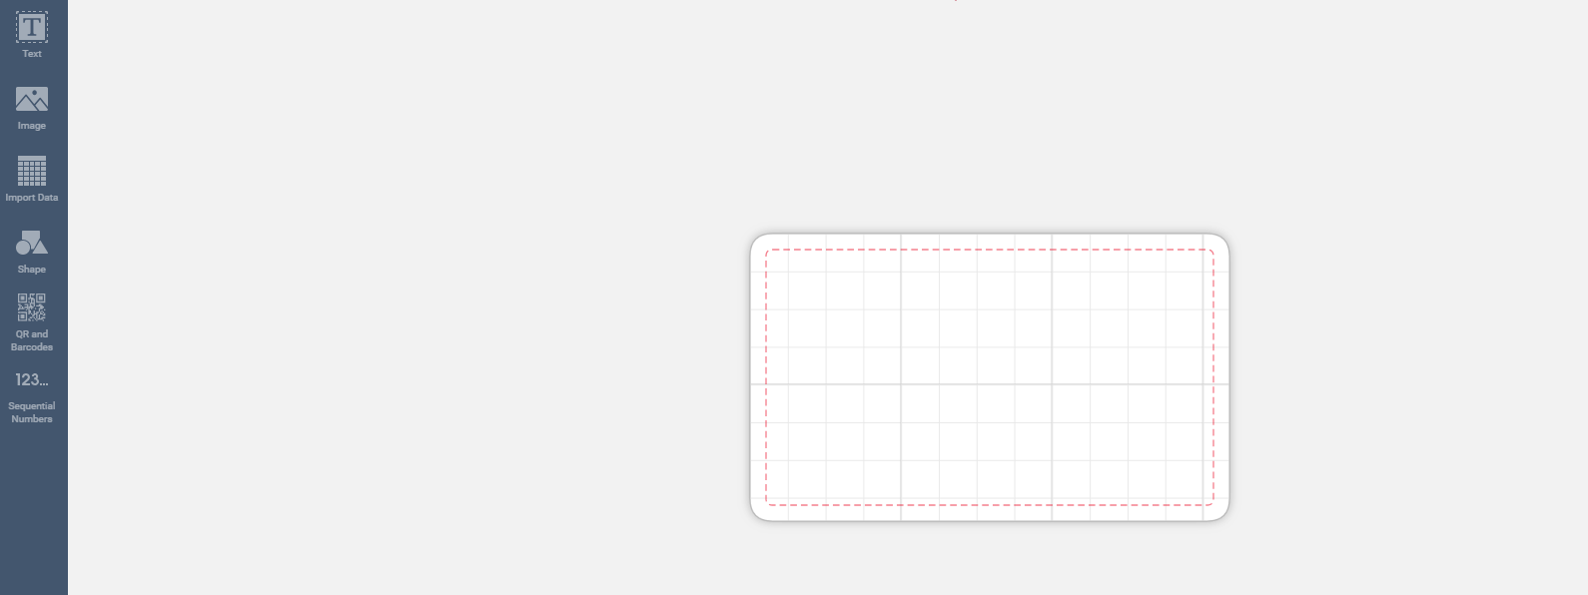
7. Screen looks like this, on the left we’re going to pick import data

8. We now need to find the file with addresses in, there’s a sample embedded below, save that to downloads folder so let’s Start import/Merge. If you need it there is a link to a video, but you’re safe with me..
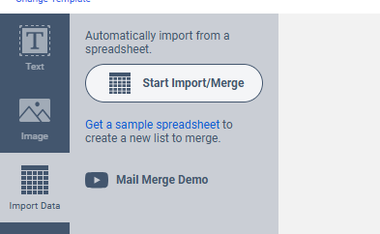

9. Browse for the file
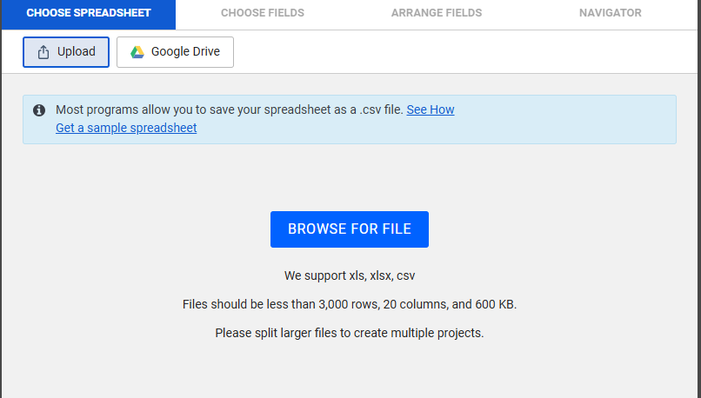

10. Here it is
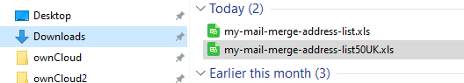

11. Let’s read in the file
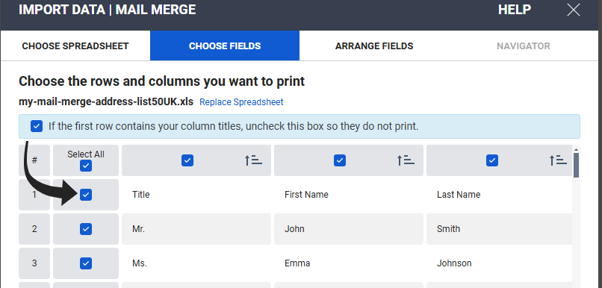

12. As indicated we’ll untick the first row as that has our field names..
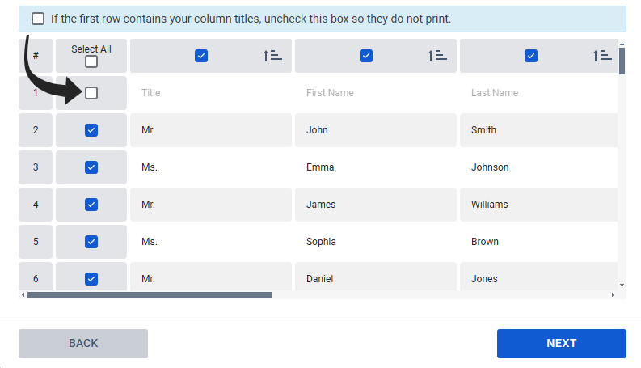

13. And select next and we’re going to build our label template.
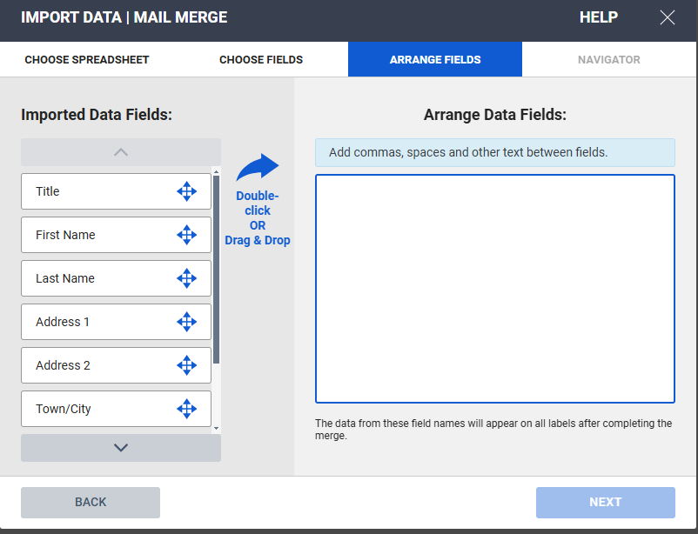

14. Drag the boxes so it looks like this and click next
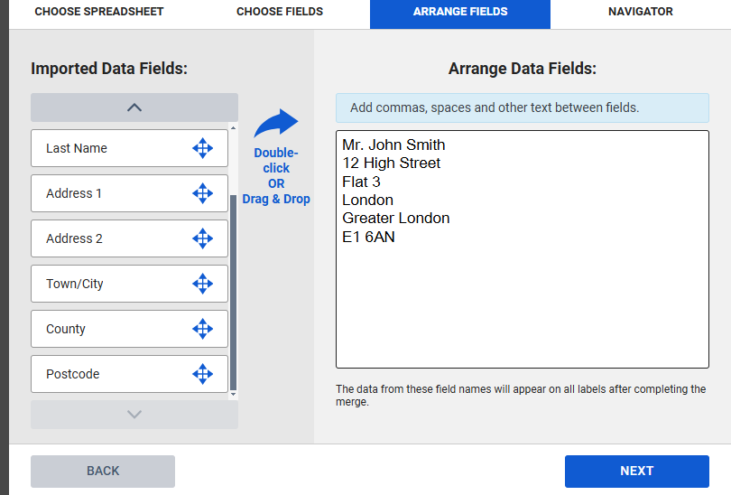

15. The next window maybe confusing, but just click finish
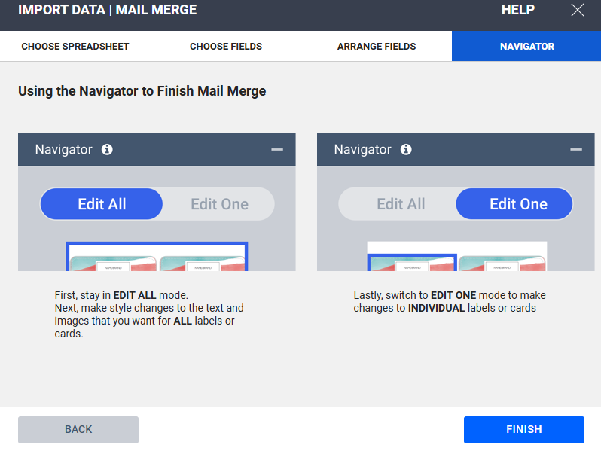

16. There’s a lot going on in the next window, key options pointed out below
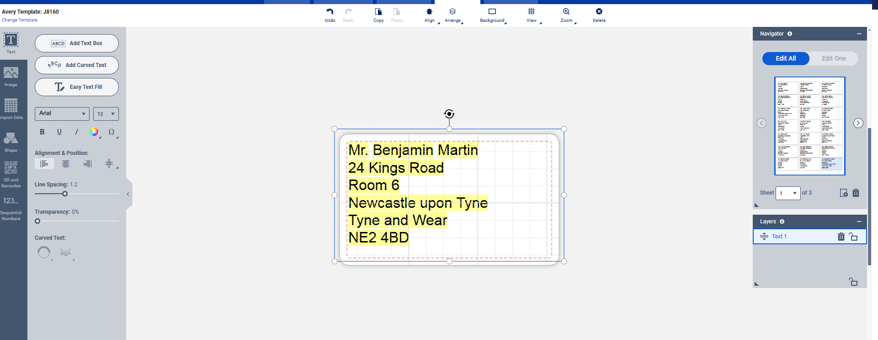

Change Font
Spacing
All or single

17. Lots of others things you can change, experiment once you are confident. In the bottom right hand corner there is preview and print

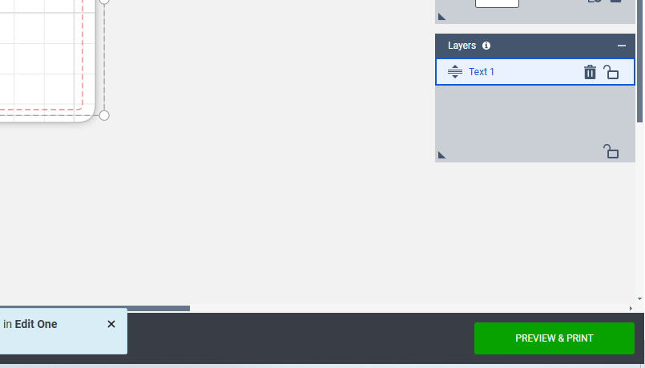

18. Preview and then print
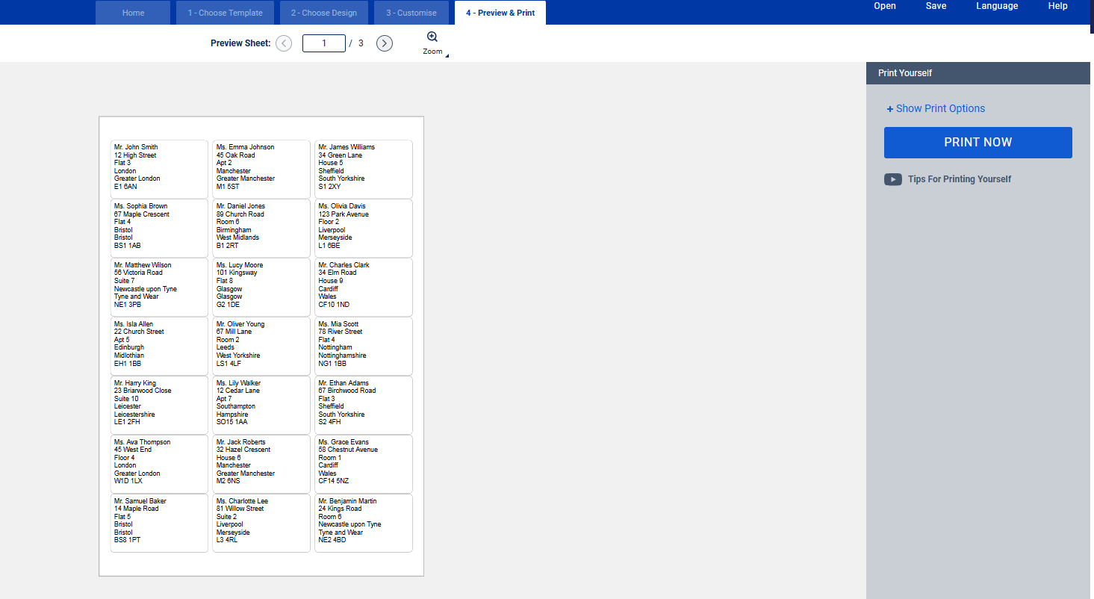

19. You can create an account and save your work to Avery, or save as a pdf. For this exercise we’re not going to save as recreating is pretty straight forward..

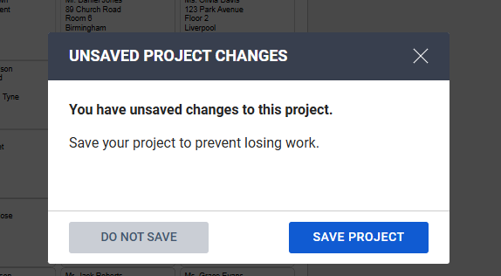

12. Note the printing tips, do not use shrink to fit, you need 100% and then download as PDF.

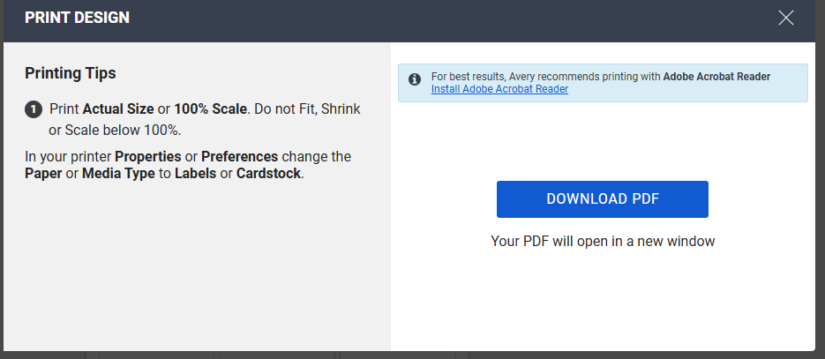

13. The download saves to your downloads folder as a PDF where you can print it. Suggest printing one page to plain paper to save wasting labels.

14. Now you’ve done that, look at all the other options you could add. Oh joy!

Colin

Title | First Name | Last Name | Address 1 | Address 2 | Town/City | County | Postcode
Mr. | John | Smith | 12 High Street | Flat 3 | London | Greater London | E1 6AN
Ms. | Emma | Johnson | 45 Oak Road | Apt 2 | Manchester | Greater Manchester | M1 5ST
Mr. | James | Williams | 34 Green Lane | House 5 | Sheffield | South Yorkshire | S1 2XY
Ms. | Sophia | Brown | 67 Maple Crescent | Flat 4 | Bristol | Bristol | BS1 1AB
Mr. | Daniel | Jones | 89 Church Road | Room 6 | Birmingham | West Midlands | B1 2RT
Ms. | Olivia | Davis | 123 Park Avenue | Floor 2 | Liverpool | Merseyside | L1 6BE
Mr. | Matthew | Wilson | 56 Victoria Road | Suite 7 | Newcastle upon Tyne | Tyne and Wear | NE1 3PB
Ms. | Lucy | Moore | 101 Kingsway | Flat 8 | Glasgow | Glasgow | G2 1DE
Mr. | Charles | Clark | 34 Elm Road | House 9 | Cardiff | Wales | CF10 1ND
Ms. | Isla | Allen | 22 Church Street | Apt 5 | Edinburgh | Midlothian | EH1 1BB
Mr. | Oliver | Young | 67 Mill Lane | Room 2 | Leeds | West Yorkshire | LS1 4LF
Ms. | Mia | Scott | 78 River Street | Flat 4 | Nottingham | Nottinghamshire | NG1 1BB
Mr. | Harry | King | 23 Briarwood Close | Suite 10 | Leicester | Leicestershire | LE1 2FH
Ms. | Lily | Walker | 12 Cedar Lane | Apt 7 | Southampton | Hampshire | SO15 1AA
Mr. | Ethan | Adams | 67 Birchwood Road | Flat 3 | Sheffield | South Yorkshire | S2 4FH
Ms. | Ava | Thompson | 45 West End | Floor 4 | London | Greater London | W1D 1LX
Mr. | Jack | Roberts | 32 Hazel Crescent | House 6 | Manchester | Greater Manchester | M2 6NS
Ms. | Grace | Evans | 58 Chestnut Avenue | Room 1 | Cardiff | Wales | CF14 5NZ
Mr. | Samuel | Baker | 14 Maple Road | Flat 5 | Bristol | Bristol | BS8 1PT
Ms. | Charlotte | Lee | 81 Willow Street | Suite 2 | Liverpool | Merseyside | L3 4RL
Mr. | Benjamin | Martin | 24 Kings Road | Room 6 | Newcastle upon Tyne | Tyne and Wear | NE2 4BD
Ms. | Zoe | Garcia | 45 Victoria Crescent | Floor 3 | Glasgow | Glasgow | G3 8RG
Mr. | Oscar | Harris | 10 Park Avenue | Flat 1 | Leeds | West Yorkshire | LS2 9AQ
Ms. | Megan | Allen | 56 River Road | Room 8 | Nottingham | Nottinghamshire | NG2 4QN
Mr. | Liam | Young | 33 Elm Street | House 7 | Southampton | Hampshire | SO14 3PB
Ms. | Emily | Wright | 67 Birch Lane | Suite 5 | Birmingham | West Midlands | B4 7TL
Mr. | Joshua | Jackson | 18 Cedar Avenue | Flat 9 | Edinburgh | Midlothian | EH3 5FN
Ms. | Amelia | White | 23 Greenfield Close | Room 7 | Cardiff | Wales | CF23 5AB
Mr. | Henry | Lopez | 45 North Road | Flat 6 | London | Greater London | N1 7NN
Ms. | Poppy | Thomas | 78 Oak Crescent | Floor 10 | Glasgow | Glasgow | G5 9NR
Mr. | George | Martinez | 12 West End Street | Suite 3 | Leicester | Leicestershire | LE3 1JW
Ms. | Hannah | Allen | 22 Birchwood Road | House 5 | Bristol | Bristol | BS7 8NB
Mr. | Leo | Evans | 47 Rose Avenue | Flat 4 | Leeds | West Yorkshire | LS6 9EB
Ms. | Ivy | Morris | 11 Mill Lane | Room 9 | Southampton | Hampshire | SO16 4AA
Mr. | Sebastian | Robinson | 30 Pine Crescent | Flat 3 | Birmingham | West Midlands | B15 2LP
Ms. | Lola | Thompson | 21 Maple Street | Floor 7 | Manchester | Greater Manchester | M3 6HG
Mr. | Isaac | Walker | 56 Victoria Lane | Suite 1 | Nottingham | Nottinghamshire | NG5 5XP
Ms. | Eliza | Green | 34 Queen's Road | Room 4 | Cardiff | Wales | CF10 3JU
Mr. | Aiden | Adams | 67 Forest Street | Apt 8 | Edinburgh | Midlothian | EH4 1PB
Ms. | Sophie | Roberts | 102 High Road | Floor 6 | London | Greater London | N4 3DU
Mr. | Jacob | Scott | 13 Briarwood Lane | Flat 5 | Southampton | Hampshire | SO15 7BD
Ms. | Luna | Clark | 45 Chestnut Close | Room 3 | Leicester | Leicestershire | LE2 7BL
Mr. | Maxwell | Brown | 22 Rose Street | Flat 7 | Sheffield | South Yorkshire | S3 7AF
Ms. | Ella | Martin | 77 Park Crescent | Suite 2 | Bristol | Bristol | BS9 1RA
Mr. | Nathan | King | 89 Maple Crescent | House 6 | Liverpool | Merseyside | L8 3DD
Ms. | Freya | Miller | 19 Victoria Road | Flat 4 | Newcastle upon Tyne | Tyne and Wear | NE3 5AW
Mr. | Theo | Jackson | 34 Hazel Road | Room 2 | Manchester | Greater Manchester | M19 2QW
Ms. | Lucy | Young | 10 Pine Crescent | Apt 1 | Cardiff | Wales | CF11 6YF
Mr. | Samuel | Martinez | 23 Elm Lane | Flat 6 | Leeds | West Yorkshire | LS1 4NL
Ms. | Eva | Lopez | 77 North Street | House 7 | Southampton | Hampshire | SO14 1BQ
Mr. | Joshua | White | 55 Kings Avenue | Floor 2 | Glasgow | Glasgow | G12 8JP
Ms. | Victoria | Robinson | 44 Chestnut Road | Flat 3 | Birmingham | West Midlands | B18 6PH
Mr. | Ryan | Green | 21 Maple Avenue | Suite 10 | Nottingham | Nottinghamshire | NG1 6QD
Ms. | Charlotte | Morris | 34 Victoria Crescent | Room 8 | London | Greater London | E2 5HX
Mr. | Elliot | Harris | 11 Willow Close | Flat 2 | Manchester | Greater Manchester | M2 4AX
Ms. | Isabella | Walker | 56 Park Street | Room 5 | Leicester | Leicestershire | LE4 2SR
Mr. | Jaxon | Roberts | 29 Birch Lane | Suite 1 | Cardiff | Wales | CF24 1RJ
Ms. | Daisy | Adams | 77 Pine Road | Flat 7 | Southampton | Hampshire | SO16 6DA

